Towards Recognition of Abuse, Understanding, and Mutuality

through Arts (T.R.A.U.M.A.)

Arts Collective Application Form

Thank you for your interest in joining the T.R.A.U.M.A. project. Before you complete this form, please ensure you have read the Information Pack.

There are 4 parts to this application form:

- Part 1: Your Details
- Part 2: Your Interest and Professional Experience
- Part 3: Your Work
- Part 4: Your Identity and Lived Experience

Once complete, please send your submission to Jane (connect@survivorsvoices.org), Laura (laura@traumascapes.org) and Angie (angela.sweeney@kcl.ac.uk) with the subject line “T.R.A.U.M.A. Arts Collective” by Midnight on the 30th of September 2022.

If you have any questions or have any difficulty completing this application, you are welcome to contact us.

We look forward to hearing from you!

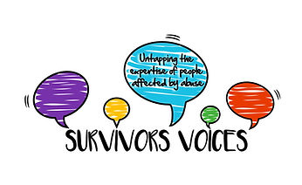
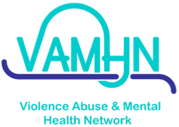
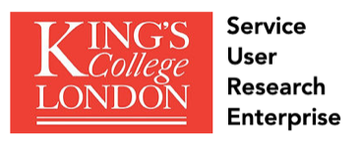
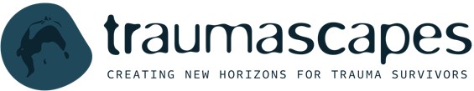
PART 1: Your Details

Your first and last name:

Your email address:

Where in the UK are you based?

In which capacity are you applying? Please highlight or underline your answer.

- Artist with lived experience of abuse
- Researcher with lived experience of abuse (based in academia, third sector, or independent)

Do you confirm that you are available on the following dates and times and able to attend in-person workshops in London?
- 31st of October from 10am to 5pm
- 7th of November from 2pm to 5pm
- 10th of November from 10am to 5pm

- Yes
- No

Are you happy for your artwork to be included in the card deck and the exhibition?

- Yes
- No

Do you have any accessibility needs for online meetings?

Do you have any accessibility needs for in-person work?

PART 2: Your Interest and Professional Experience

Please answer the following questions in a few sentences (up to 3 paragraphs per question). Please refer to the Information Pack for a description of the project and what to expect.

1. Why would you like to take part in this project?

2. From your perspective, why is it important to support abuse recognition?

3. From your perspective, how can art help make that happen?

4.1. Artists: What is your experience of using art to explore and articulate abuse and/or trauma?

4.2. Researchers: What is your experience and/or interest in using art to study or explore abuse and/or trauma? This may be with arts-based research methods, artistic components to studies you have conducted, or non-research related artistic interest and/or experience.

5. Can you describe your experience of working safely and sensitively with narratives of abuse and/or trauma?

PART 3: Your Work

All applicants

Please attach a copy of your CV or outline your educational and professional experience in a few sentences here. Please note that we do not have specific academic requirements; we are interested in knowing more about your experience and what you would bring to the project.

Artists

Which artform(s) do you prefer to work with? Select all that apply.

- Drawing
- Painting
- Illustration
- Graphic design
- Textile art
- Photography
- Film
- Animation
- Drama
- Dance
- Music
- Live art / performance art
- Poetry / creative writing
- Other: please specify.

Please attach either a portfolio, a PDF with a few examples of your artwork, or a link to a website where we can see some of your work.

Researchers

Where is your research based?

- Academic institution
- Third sector, e.g. research charity
- Survivor-led / user-led organisation
- Independent practice
- Other: please specify.

Please tell us about one or more research projects you have been part of and include links to an article, report, or other output.
PART 4: Your Identity and Lived Experience

We ask that you provide this information so that we can ensure that the group we bring together reflects a range of identities and experiences. We would greatly appreciate your help with this, but if you do not feel comfortable answering some or all of these questions, feel free to leave them blank.

Do you identify as someone who has experienced abuse? Please note that at no point will we ask you to talk about your experience. However, due to the nature of the project we will be discussing the topic of abuse.

- Yes
- No

What is your age?

- 18 – 30 years old
- 31 – 40 years old
- 41 – 50 years old
- 51 – 60 years old
- 61 – 70 years old
- 71 + years old

What is your gender identity?

What is your sexual orientation?

What is your ethnicity?

Do you identify as being disabled and/or having a mental health issue?

Do you identify as neuro-diverse?

